G(s)===

Root locus:

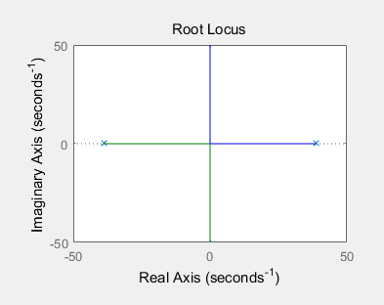

frequency response

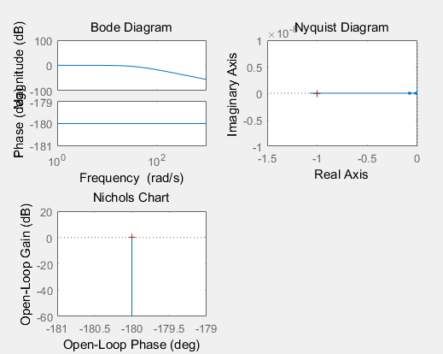

It only have 2 poles which are on the jw axis, so it’s (marginally) stable.

2. We will be adding a controller of the form G*c*(s) = to improve the performance of our system. Depending on the pole and zero locations, the compensator can be referred to as either a Lead or Lag compensator. This will be elaborated upon in later classes.

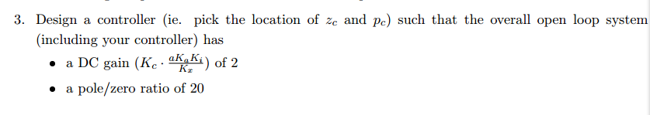

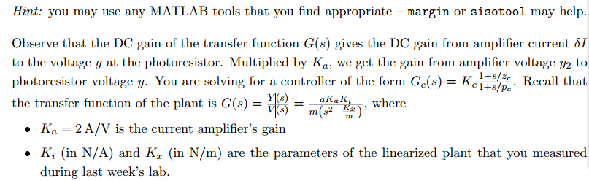

a, Ka, Ki and Kx are already known, wo make DC gain=2, we need to have a Kc= 0.93

and to satisfy pole/zero ratio is 20, I choose zero= -1 and pole= -20

The system is stable now, because when K=0.93, all poles are on the left hand of plane.

4. Using your derivations from last week’s Pre-Lab, calculate the values of R*1*, R*2*, and C to use in your circuit

C:\Users\ThinkPad\Documents\Tencent Files\879401635\FileRecv\MobileFile\Image\5U7_~{0VU)L~]B4`J)TE4%W.png

So R1==10.8KΩ and for =20\*, so 19R1=R2, so R2=204KΩ

And for = 20, so C=0.25μF.